MENU

FOOD & DRINK

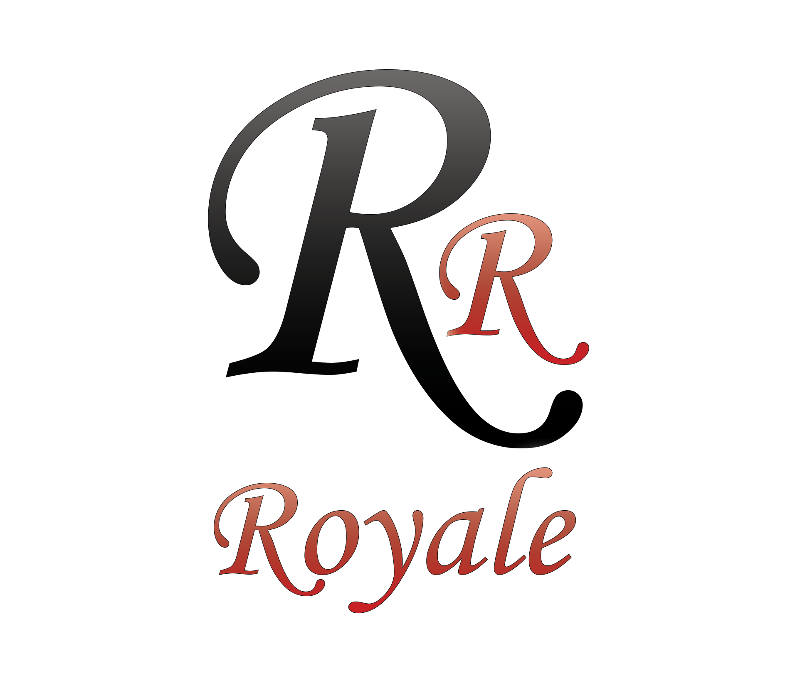

RENDEZVOUSROCHDALE.COM

THE ROCHDALE ROYALE CENTRE | PLATTING LANE | ROCHDALE | OL11 2LS